**Over The Wire**

## Level 9 to Level 10

**Step 1: SSH Login**

**Password:** **4CKMh1JI91bUIZZPXDqGanal4xvAg0JM**

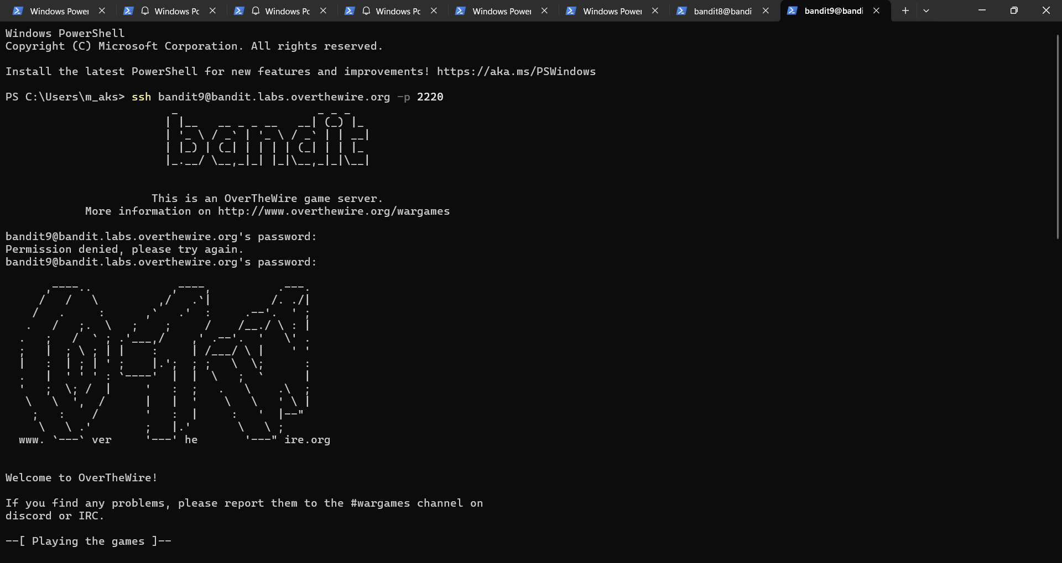

**Step 2: Extract readable text**

**strings data.txt | grep "="**

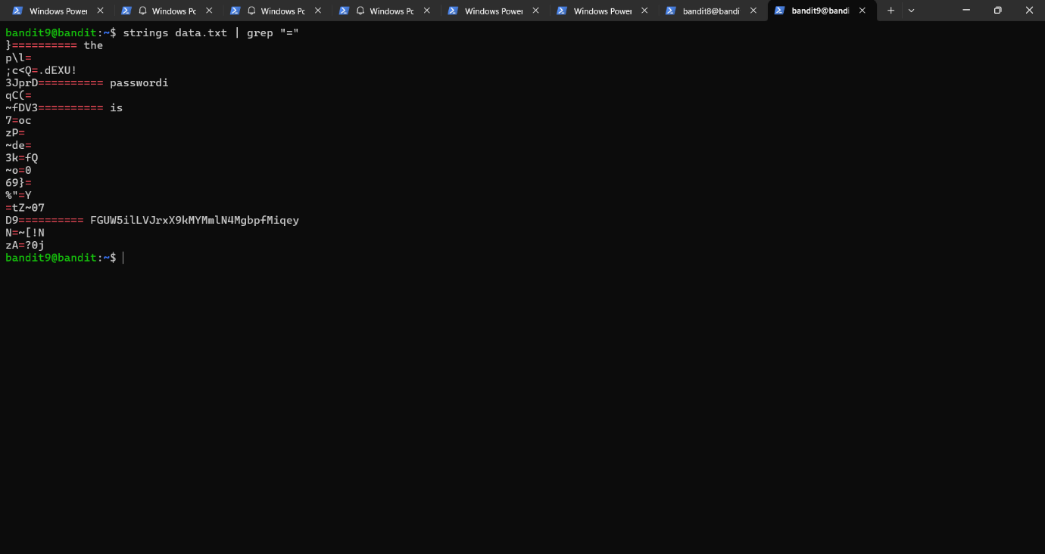

**Password:** **FGUW5ilLVJrxX9kMYMmlN4MgbpfMiqey**